Zeus was king of the gods in ancient Greek mythology.
The Olympics began in Athens as a festival of different sports held to honour Zeus.

These are the 5 Olympic rings.
They were designed in 1913 by Pierre de Coubertin.
The rings represent the 5 continents of the world.

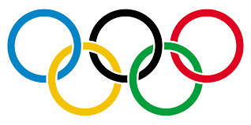
As you can see below, the Olympic rings feature in all of the logos that have been designed over the years for the Olympic games.

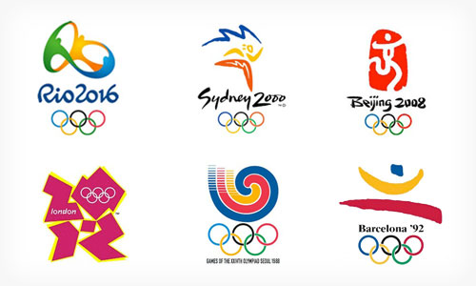

In 2020, the Olympic games were to be held in Tokyo.
These are some of the many logo designs that were created, but none of them were chosen as the final design.
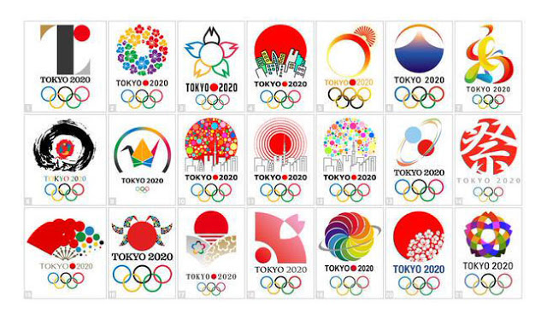
Below are the logo designs that were chosen for the
Tokyo 2020 Olympic games.
What do you think of them?
Are they the ones that you would have chosen?
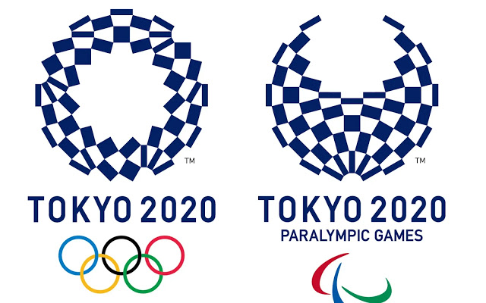
Imagine that your school needs an Olympic Logo and it is your job to design it.
Create 5 or 6 small sketches then ask your friends and family to help decide which one you are going to choose.
Once you have chosen the design, draw it on a bigger scale - improving your design as you go.

