The Armada Portrait - painted in 1588 by George Gower

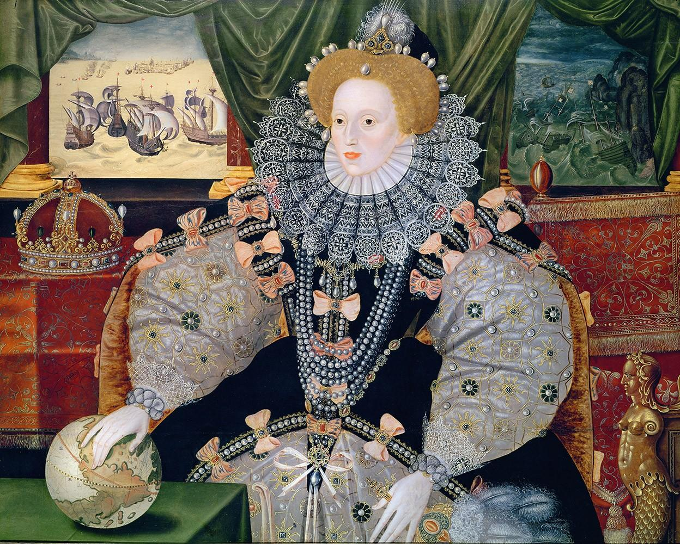

Look carefully at this painting - What can you see?

Who do you think this person is?

How do you know?

What do you think the painting tells us about the person?

If you could step inside the painting, what three questions would you ask her?

